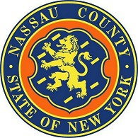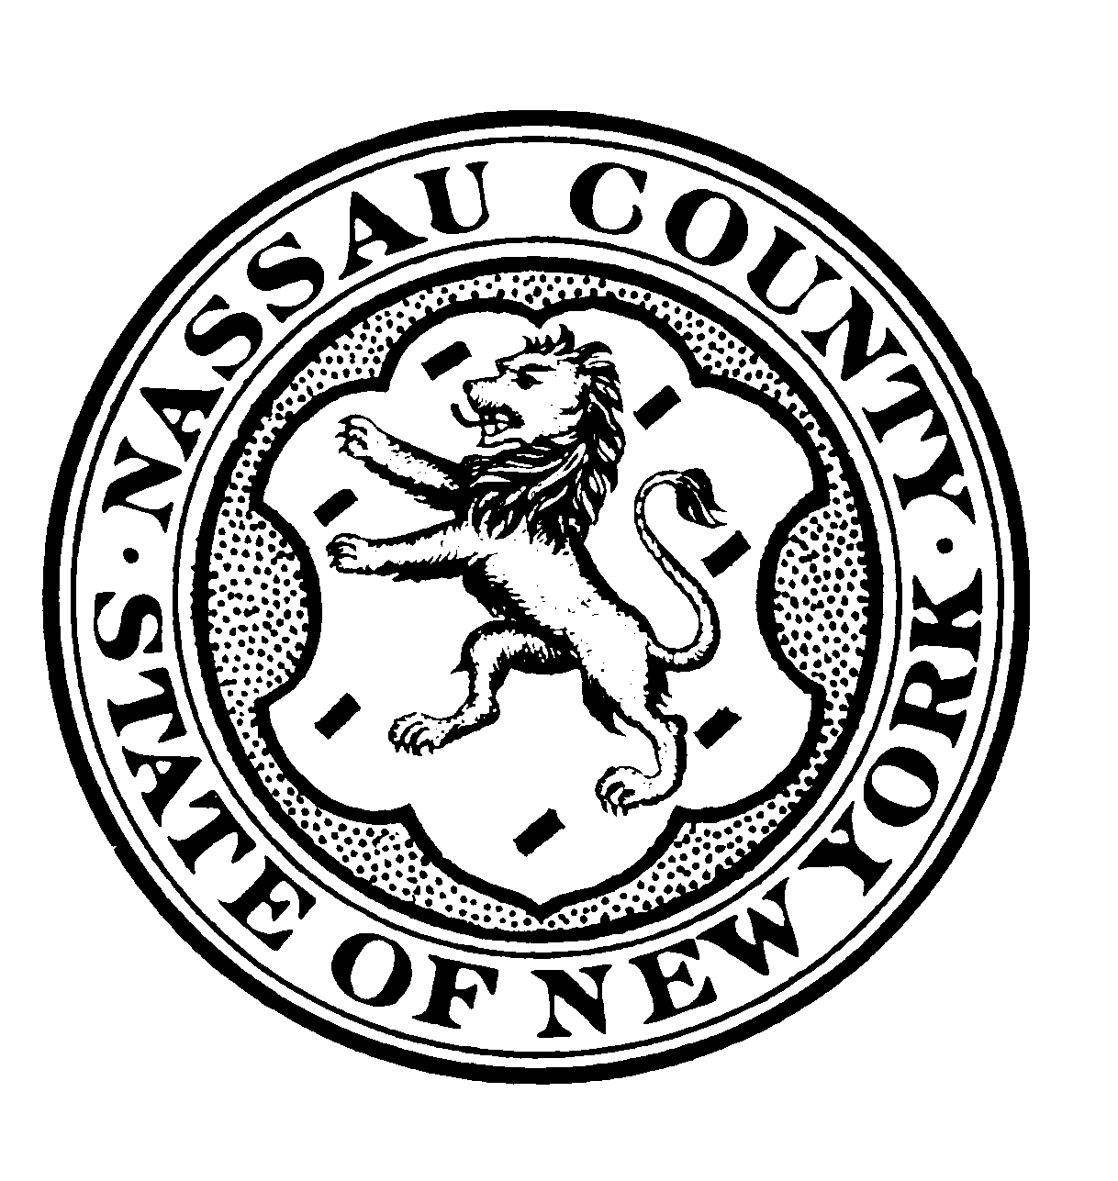

**LAURA CURRAN JARED KASSCHAU County Executive County Attorney**

**COUNTY OF NASSAU**

**OFFICE OF THE COUNTY ATTORNEY**

**One West Street**

**Mineola, New York 11501-4820**

**516-571-3056**

**Fax: 516-571-6684, 571-6604**

September 11, 2019

**Nassau County Bus Transit Committee**

**NOTICE OF MEETING**

**NOTICE IS HEREBY GIVEN** that the Nassau County Bus Transit Committee will hold a public meeting on Thursday, September 26th, 2019 with session beginning at 5:30 pm concerning the matters on the attached Agenda. This Agenda is subject to change as necessary for the Committee to conduct its business.

This meeting will be held at NICE BUS, 700 Commercial Ave, Garden City, NY 11530.